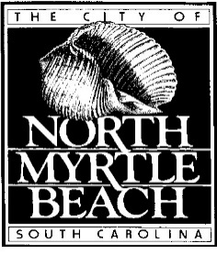

The North Myrtle Beach Board of Zoning Appeals will hold a meeting on February 12th, 2026, at 5:00 p.m. in the Council Chambers of City Hall at 1018 2nd Avenue South to discuss the following:

- BZA-25-47: Application by David Rumney for a variance to remove trees at 948 Morrall Drive.

- BZA-26-01: Application by Robert Guyton for a variance to reduce the required perimeter landscape buffer in the front and rear yard for a proposed parking lot at 1716 S. Ocean Blvd. zoned Resort Residential, R-4 District

- BZA-26-02: Application by Robert Guyton for a variance to reduce the required perimeter landscape buffer in the side yards for a proposed parking lot at 1802 S. Ocean Blvd. zoned Resort Residential, R-4 District

- BZA-26-03: Application by Robert Guyton for a variance of side yard setback for a proposed slide tower at 1717 S. Ocean Blvd. zoned Resort Residential, R-4 District

